LAB Logbook

Lab 1
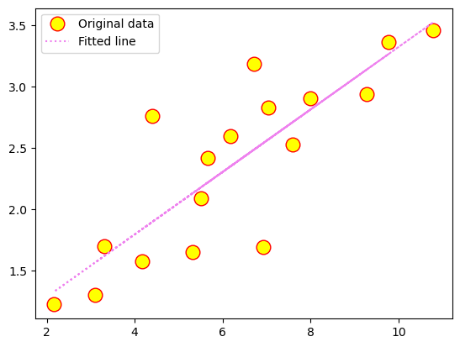
Lab 2
Test Accuracy: 0.901

Model: "sequential_1"
_________________________________________________________________
Layer (type) Output Shape Param #
=================================================================
dense_4 (Dense) (None, 64) 704

dense_5 (Dense) (None, 32) 2080

dense_6 (Dense) (None, 1) 33

=================================================================
Total params: 2817 (11.00 KB)
Trainable params: 2817 (11.00 KB)
Non-trainable params: 0 (0.00 Byte)
_________________________________________________________________
None
Model: "sequential_1"
_________________________________________________________________
Layer (type) Output Shape Param #
=================================================================
dense_4 (Dense) (None, 64) 704

dense_5 (Dense) (None, 32) 2080

dense_6 (Dense) (None, 1) 33

=================================================================
Total params: 2817 (11.00 KB)
Trainable params: 2817 (11.00 KB)
Non-trainable params: 0 (0.00 Byte)
_________________________________________________________________
None

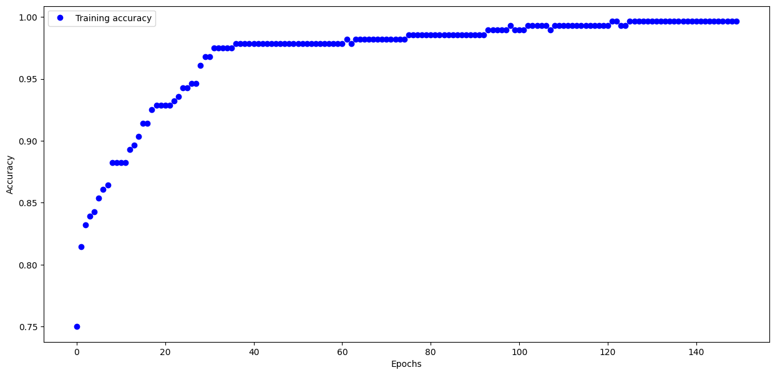
Task 2 :
O1 : 0.823
O2 : 0.823

Lab 3
Task 1:
313/313 - 0s - loss: 0.3622 - accuracy: 0.8799 - 211ms/epoch - 673us/step

Test accuracy: 0.8798999786376953

Task 2:
Model: "sequential"
_________________________________________________________________
Layer (type) Output Shape Param #
=================================================================
flatten (Flatten) (None, 784) 0

dense (Dense) (None, 69) 54165

dense_1 (Dense) (None, 96) 6720

dense_2 (Dense) (None, 129) 12513

dense_3 (Dense) (None, 229) 29770

dense_4 (Dense) (None, 329) 75670

dense_5 (Dense) (None, 12) 3960

=================================================================
Total params: 182798 (714.05 KB)
Trainable params: 182798 (714.05 KB)
Non-trainable params: 0 (0.00 Byte)
_________________________________________________________________

Lab 4
Task1: History of Losses after every Epoch
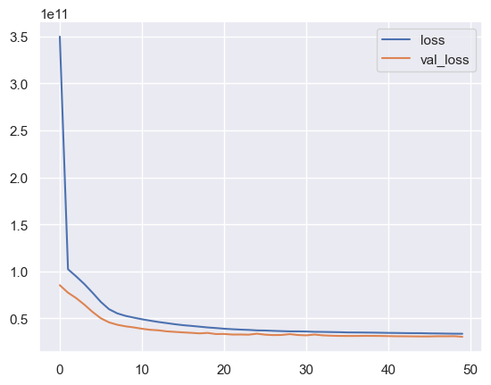
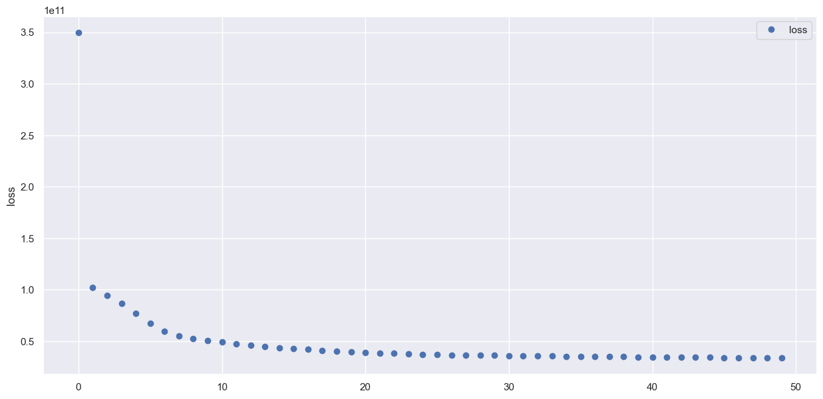

Task2: Model summary
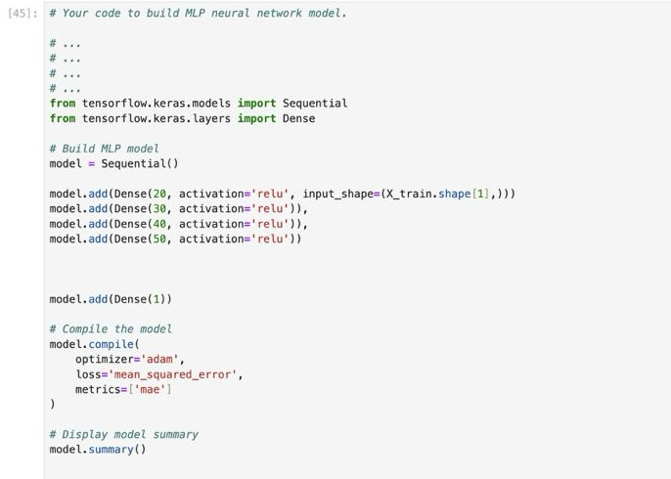

Model: "sequential"
_________________________________________________________________
Layer (type) Output Shape Param #
=================================================================
dense (Dense) (None, 20) 400

dense_1 (Dense) (None, 30) 630

dense_2 (Dense) (None, 40) 1240

dense_3 (Dense) (None, 50) 2050

dense_4 (Dense) (None, 1) 51

=================================================================
Total params: 4371 (17.07 KB)
Trainable params: 4371 (17.07 KB)
Non-trainable params: 0 (0.00 Byte)
_________________________________________________________________

Lab 5
Task1: Model building code and model summary.
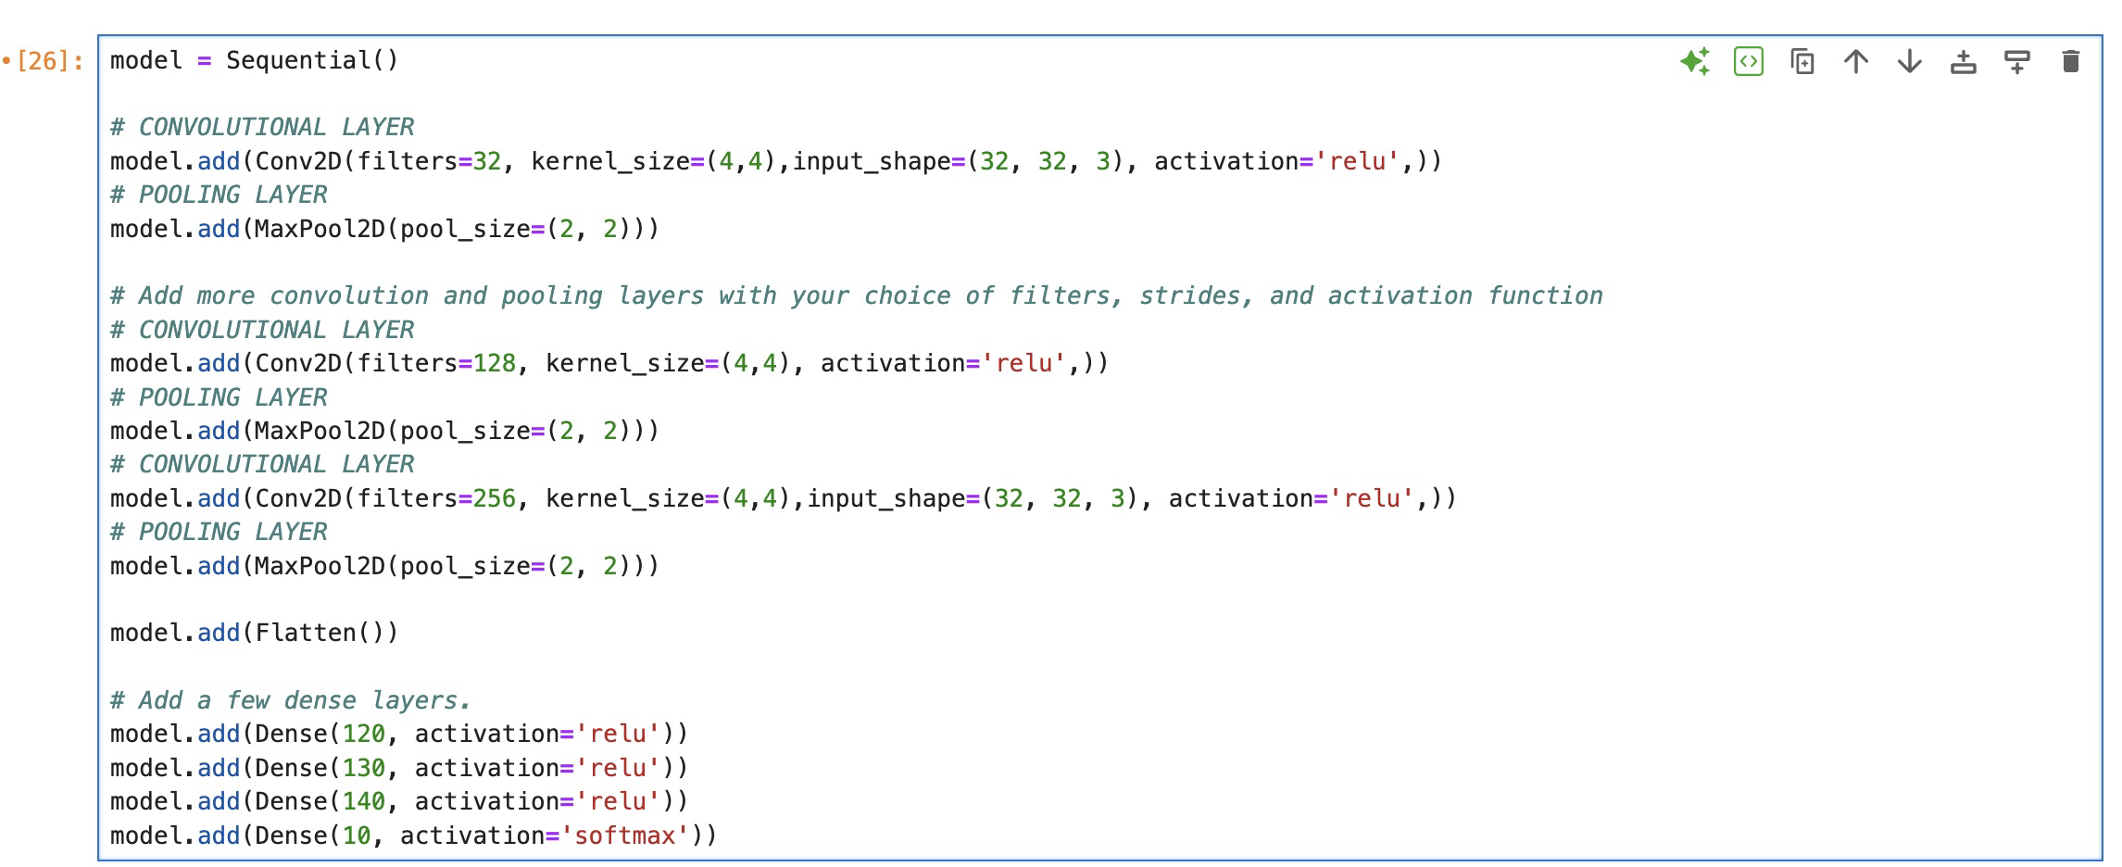
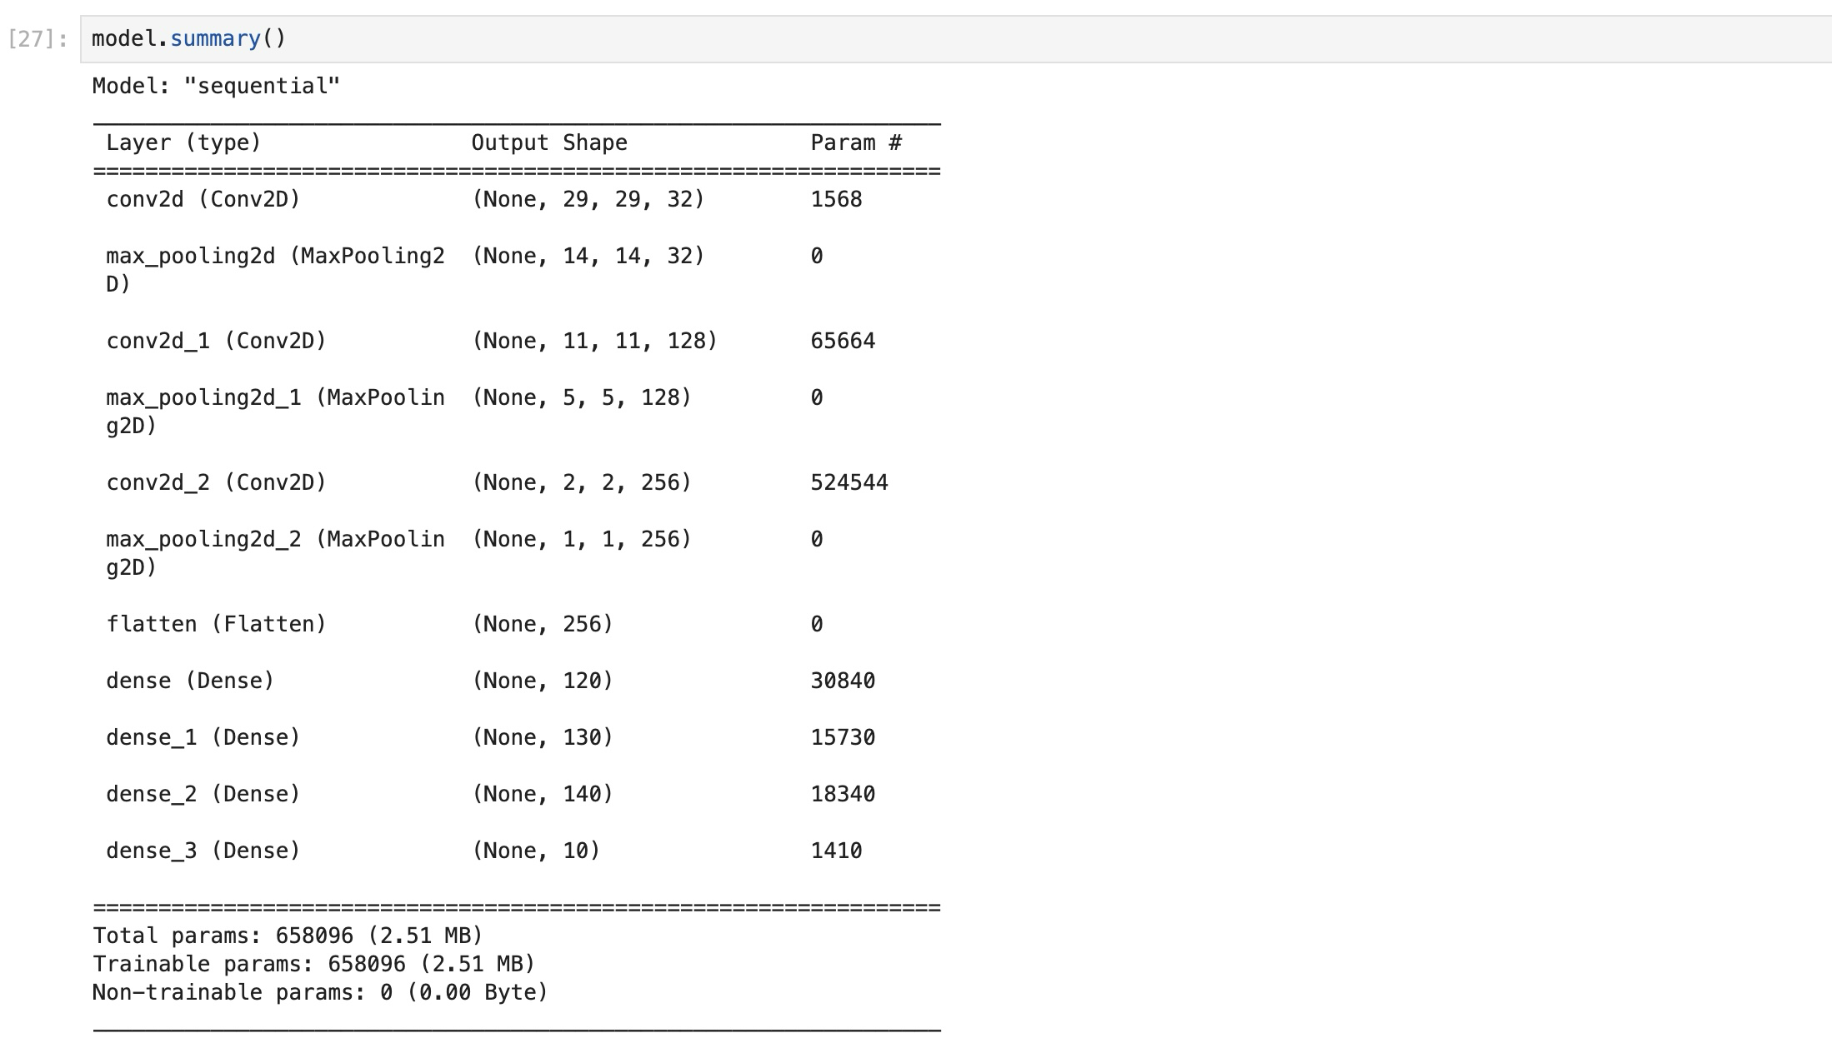

Task 2: Graphical representation depicting the train loss and validation loss trends (4 graphs)
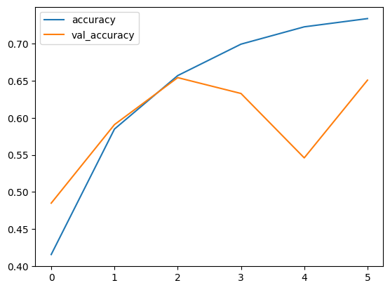

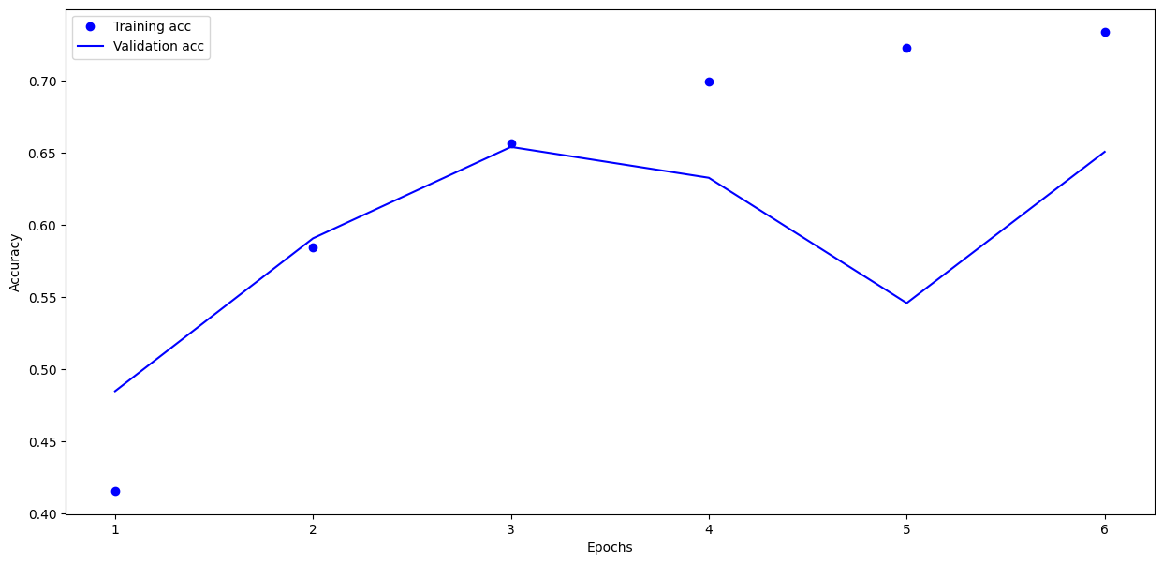



Lab 6
1.
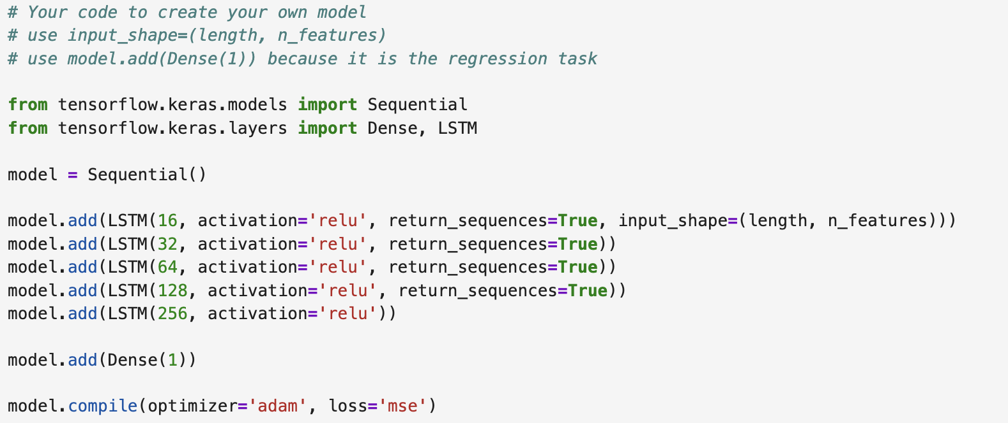

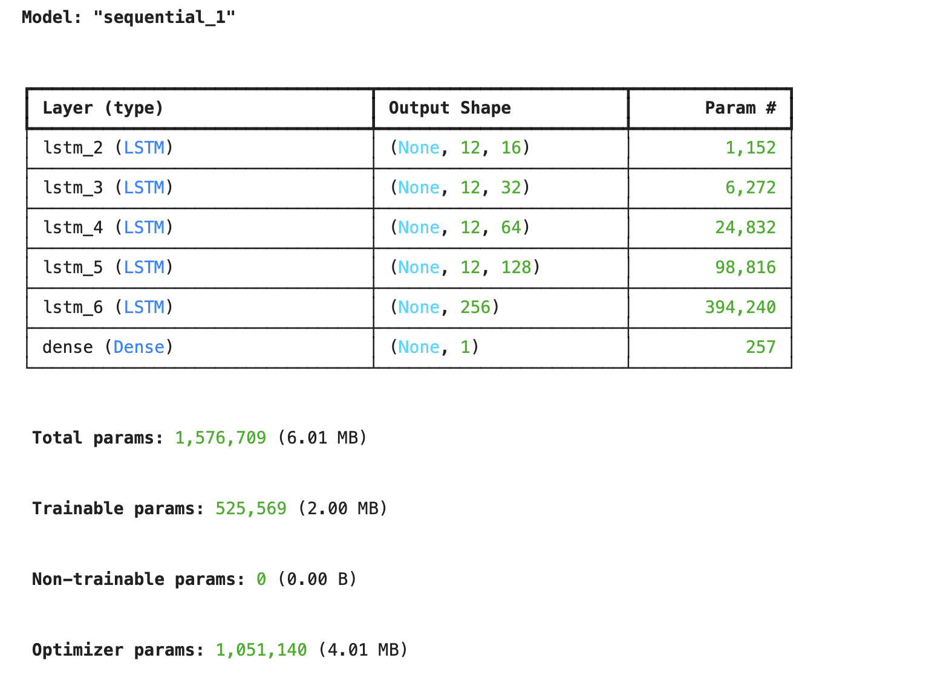
2.
early_stop = EarlyStopping(monitor='val_loss',patience=9)
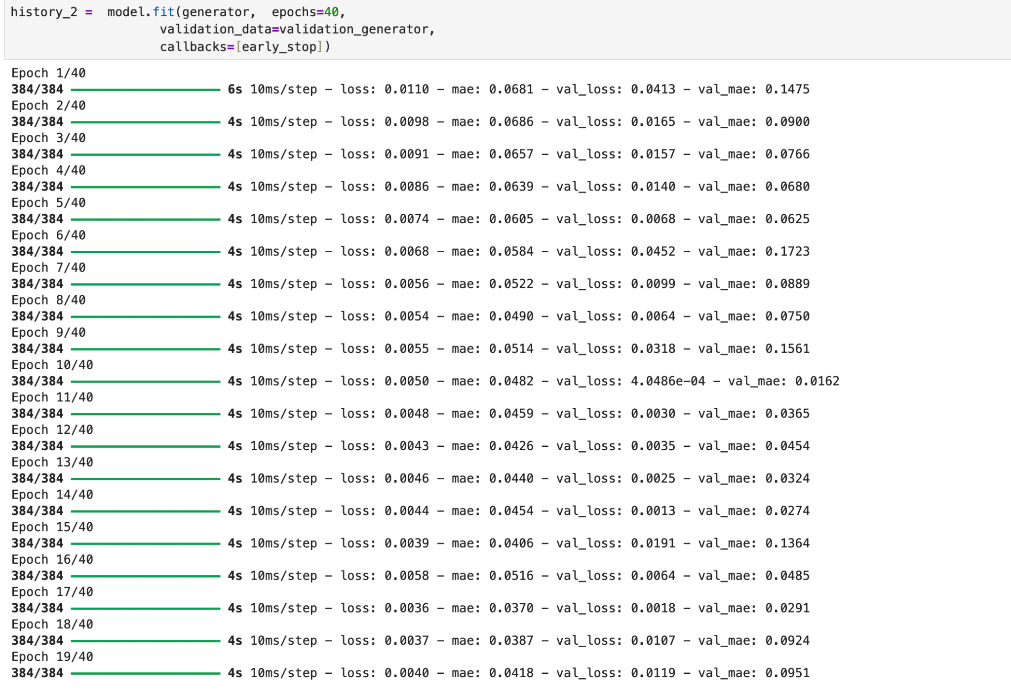
3. Plot of Validation
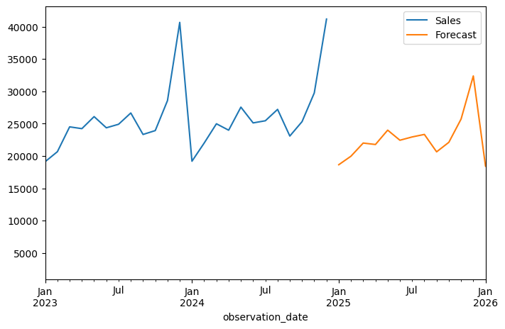
Test Loss
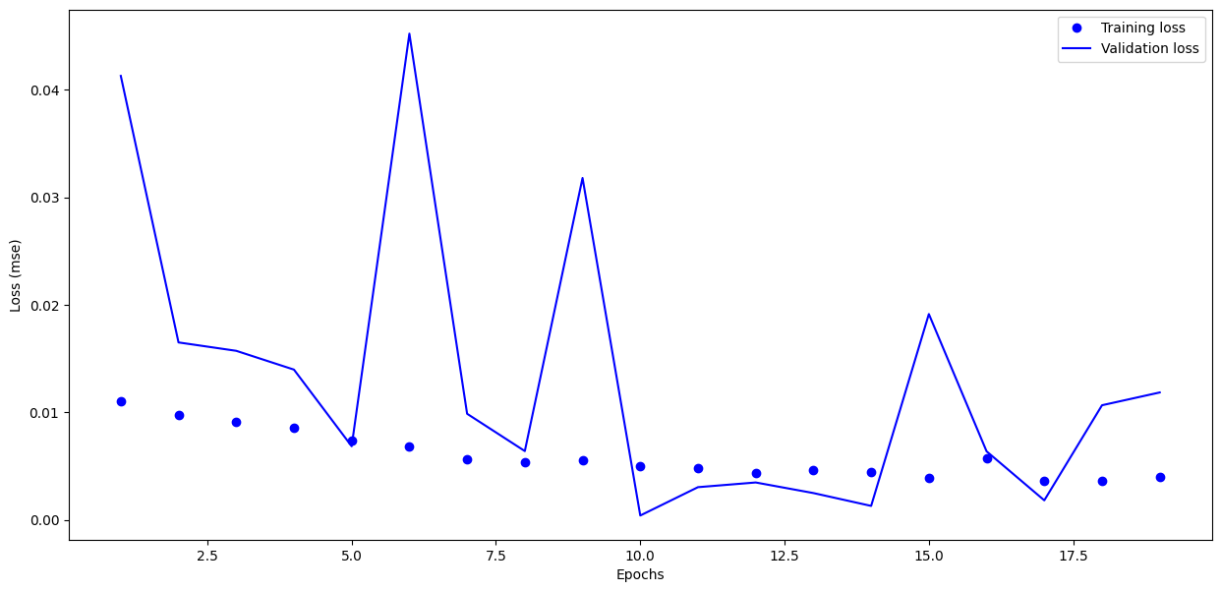
4. Optimal number of Epochs =10.
5.Plot of the Checking Forecast for the last 12 months.

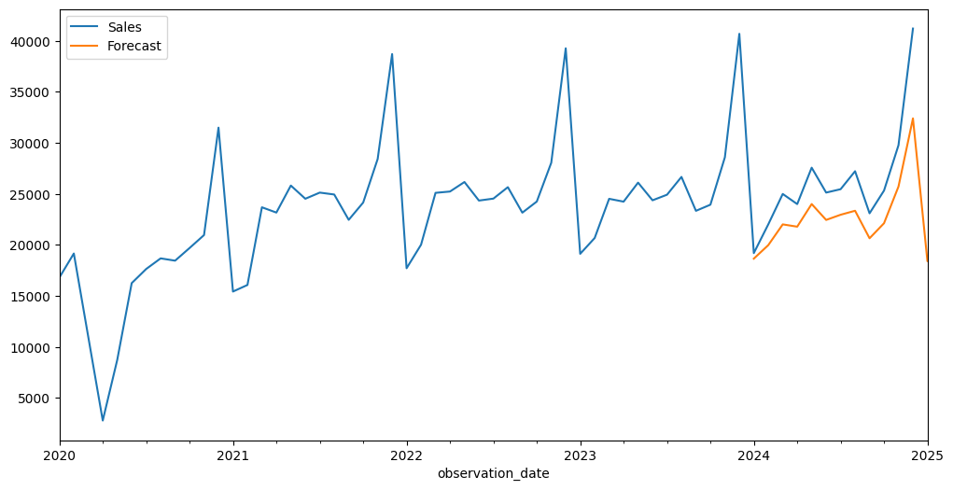

Lab 7

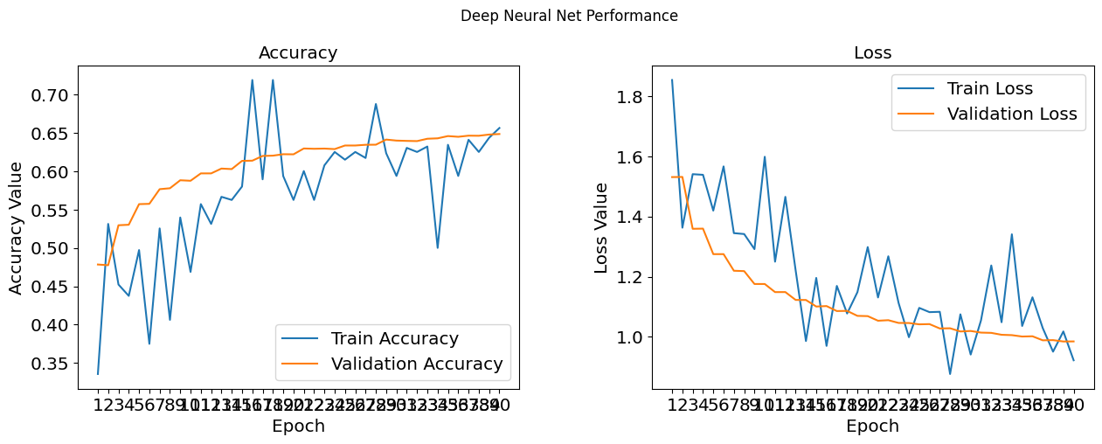

- 24

- early_stop = EarlyStopping(monitor='val_loss',patience=19)

- precision recall f1-score support
0 0.55 0.55 0.55 1000
1 0.56 0.59 0.58 1000
2 0.41 0.29 0.34 1000
3 0.35 0.33 0.34 1000
4 0.42 0.45 0.43 1000
5 0.44 0.37 0.40 1000
6 0.49 0.58 0.53 1000
7 0.51 0.59 0.54 1000
8 0.65 0.66 0.65 1000
9 0.55 0.58 0.56 1000
accuracy 0.50 10000
macro avg 0.49 0.50 0.49 10000
weighted avg 0.49 0.50 0.49 10000

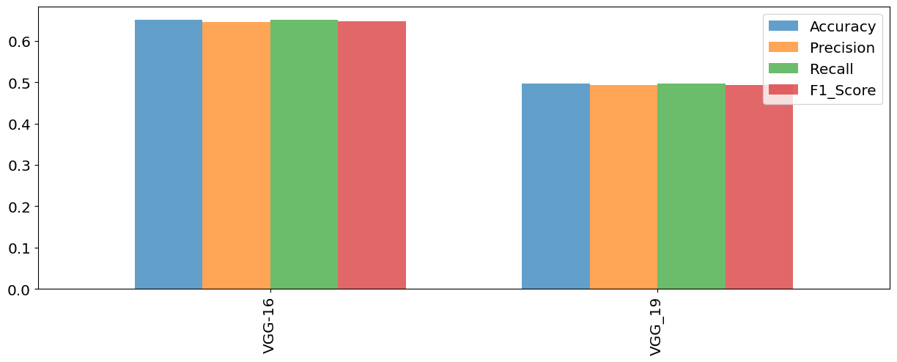

Lab 8
Model Summary
Model: "sequential"

┏━━━━━━━━━━━━━━━━━━━━━━━━━━━━━━━━━┳━━━━━━━━━━━━━━━━━━━━━━━━┳━━━━━━━━━━━━━━━┓
┃ Layer (type) ┃ Output Shape ┃ Param # ┃
┡━━━━━━━━━━━━━━━━━━━━━━━━━━━━━━━━━╇━━━━━━━━━━━━━━━━━━━━━━━━╇━━━━━━━━━━━━━━━┩
│ lstm (LSTM) │ (None, 100) │ 47,600 │
├─────────────────────────────────┼────────────────────────┼───────────────┤
│ dense (Dense) │ (None, 2) │ 202 │
└─────────────────────────────────┴────────────────────────┴───────────────┘

Total params: 47,802 (186.73 KB)

Trainable params: 47,802 (186.73 KB)

Non-trainable params: 0 (0.00 B)
None
model fit
history = model.fit(X_train, y_train, batch_size=20, epochs=20,
validation_split=0.1,
verbose=1, callbacks=[es, mc])

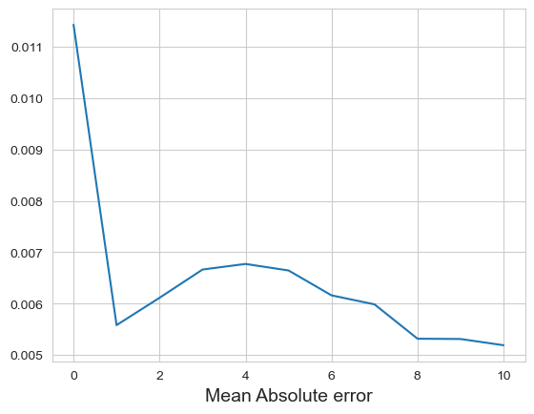
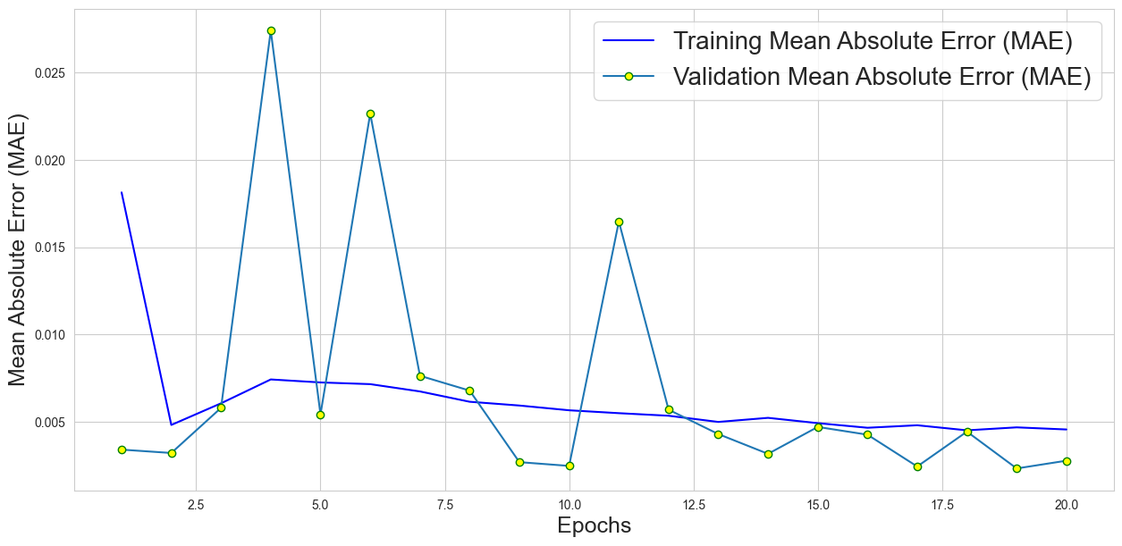

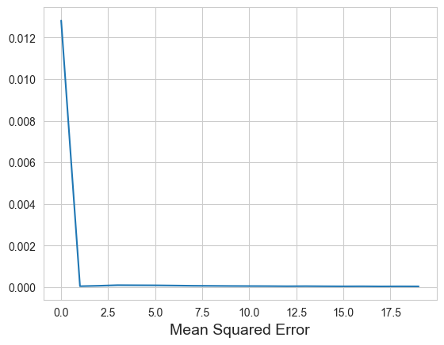
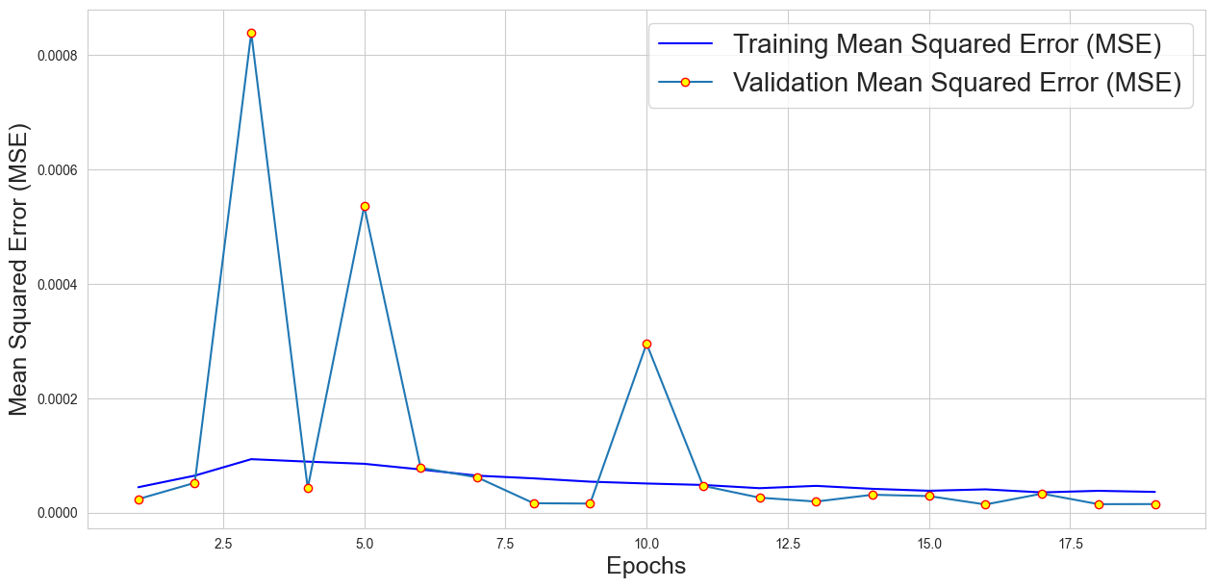
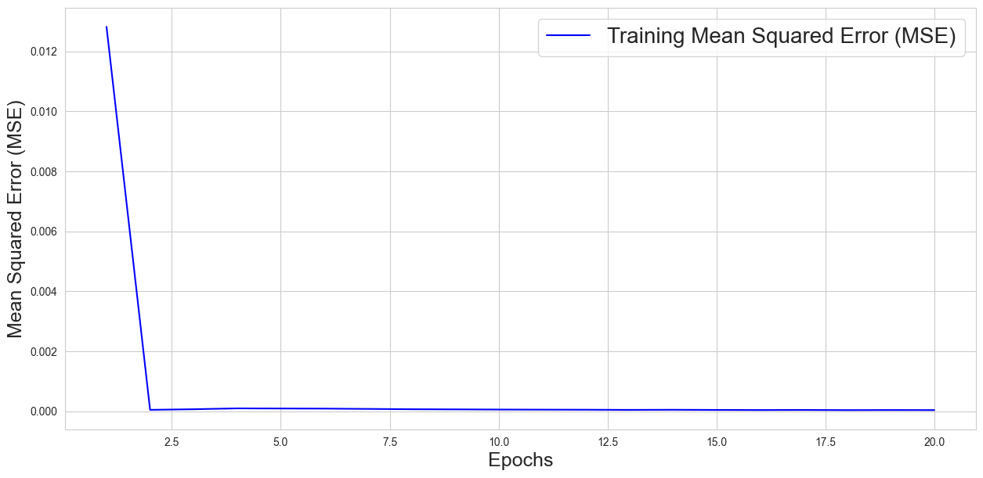

Lab 9

Lab 10

Lab 11

Lab 12

